We consider a portfolio fully invested in four risky assets (A, B, C, D). Denoted by w_{i} the weight invested in asset i, i = A, B, C, D.
Since all of the weight must be invested in the assets, the proportion of wealth invested in the various assets must equal 100% of wealth. This leads to the budget equation expresses in matrix notation w^{T}1_{N} = 1.
a)
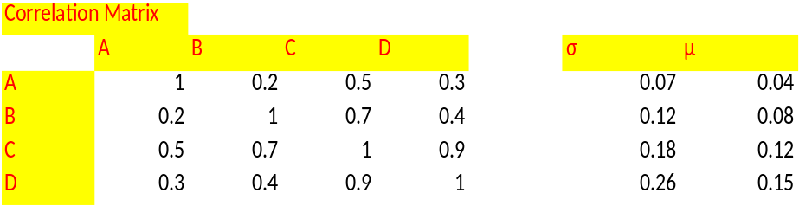
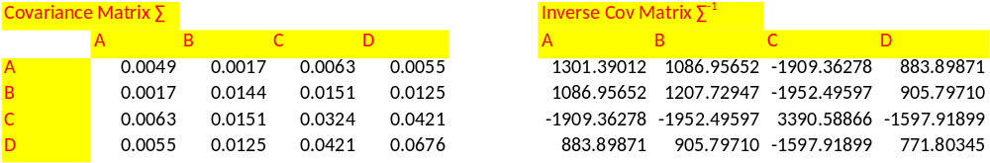
b)
Our objective function is the portfolio variance, and we will minimize it with respect to the portfolio weights. Actually, instead of using the portfolio variance, we will use a factor of ½ to ease our calculations. Since the factor is positive, it does not affect the value of the optimal vector of the weights w*.

